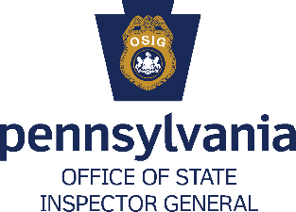
Administrative and Clerical Positions
___________________________________________________________________________
Job Overview
Pennsylvania Office of State Inspector General (OSIG) administrative and clerical employees are essential in directly supporting the OSIG mission to fight fraud, waste, and abuse in government. They perform a wide range of functions and each position is unique. Just a few examples of administrative/clerical jobs at the OIG include:

• Compiling reports and maintaining data on cases and claims.

• Responding to calls on the OSIG toll free fraud tip line.

• Supporting a unit or manager by handling correspondence, phone calls, reports, and more.

• Developing policies and procedures, analyzing trends in program activity.

• Managing personnel administration, budget, procurement, and facilities.

Minimum Experience and Training
The Minimum Experience and Training for Administrative and Clerical positions vary based on the level of the position and its responsibilities. For additional information on please visit www.careers.employment.pa.gov.

Application Instructions
- Go to www.employment.pa.gov.
- You’ll see an option for “Returning Applicants: Non-Civil Service - Log in to update your information or apply for additional job opportunities.” Select “Job Opportunities.”
- Scroll down to the bottom of the page to the list of positions and select either “Administrative Officer/Assistant Positions” or “Clerical Support Positions”.
- Select “Apply.”
- If you have an existing profile, log in. If not, select “Create Your Account Here.”
- Follow the onscreen instructions to submit your information.

