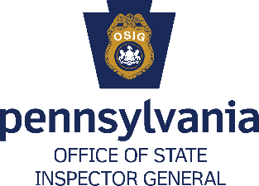
Special Agent
___________________________________________________________________________
Job Overview
Special Agents (Agents) at the Pennsylvania Office of State Inspector (OSIG) are an indispensable force charged with safeguarding the integrity of Commonwealth’s public assistance programs. Agents are tasked with conducting two types of investigations:
- investigations that will prevent the incorrect payment of public assistance benefits prior to authorization;
- investigations to recover incorrectly paid public assistance benefits ensuring that those fuds are repaid to the Commonwealth. Here, agents have the ability to use both Federal and State statutes to prosecute claims of overpaid benefits that meet the elements of welfare fraud.

Agents conduct in-depth investigations into the following public assistance programs: Medical Assistance, Cash Assistance, Subsidized Child Care, Supplemental Nutrition Assistance Program, and the Low Income Home Energy Assistance Program.

Agents investigate referrals by collecting and analyzing information on both applicants and recipients of public assistance and determining proper course and scope of investigations. They use their independent judgment in carrying out assignments while conducting investigations in their assigned territories. Agents gather evidence, prepare witness testimony, and present arguments at the preliminary stages of cases within the respective criminal/administrative court They also serve as witness for the prosecution at later stages of the criminal court process.

Minimum Experience and Training
- One year of investigative experience and a bachelor’s degree; or
- An equivalent combination of experience and training.
Special Requirements

- All positions require possession of an active Pennsylvania non-commercial Class C driver’s license or equivalent.
• All employees must obtain CLEAN/NCIC certification within two months of employment and maintain this certification for the duration of employment in this job.
Application Instructions
- Go to www.employment.pa.gov.
- Click on the blue box labeled “OPEN JOBS”.
- Click “Open to Public”.
- Click the Filter button and select Executive Offices using the Department filter.
- Select the job title you are interested in and click the green button to apply.

