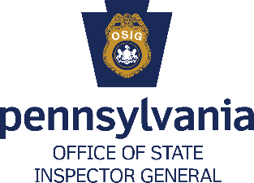
Special Investigator
___________________________________________________________________________
Job Overview
Pennsylvania Office of State Inspector General Special Investigators work in a highly energetic enterprise to eradicate fraud, abuse, and misconduct in Commonwealth Executive Agencies under the Governor’s jurisdiction.

Investigating responsibilities include, but are not limited to, ensuring contract integrity, conducting programmatic reviews, performing employee background checks, and performing special investigations when requested by senior members of executive agencies. Special Investigators enjoy varied and diverse opportunities to develop and hone investigative skills and talents as they are assigned the respective functions of reviewing documents, conducting interviews, analyzing data, reporting problems and deficiencies in programs, operations and contracting.

Special Investigators review complaints and recommend appropriate action. A high level of confidentiality is placed on Special Investigators fact-finding reports.

Minimum Experience and Training

Special Investigator 1:
- Four years of experience conducting criminal, civil, or administrative investigations; or
- A bachelor’s degree; or
- An equivalent combination of experience and training.
Special Investigator 2:
- Two years as a Special Investigator 1, OSIG (commonwealth title); or
- Two years as a Special Investigator 1 (commonwealth title); or
- Four years of experience conducting criminal, civil, or administrative investigations, and a bachelor’s degree; or
- Eight years of experience conducting criminal, civil, or administrative investigations; or
- An equivalent combination of experience and training.
Senior Special Investigator:
- Two years as a Special Investigator 2, OSIG (commonwealth title); or
- Two years as a Special Investigator 2 (commonwealth title); or
- Five years of experience conducting criminal, civil, or administrative investigations, and a bachelor’s degree; or
- Nine years of experience conducting criminal, civil, or administrative investigations; or
- An equivalent combination of experience and training.

Special Requirements

- All positions require possession of an active Pennsylvania non-commercial Class C driver’s license or equivalent.
- All employees must obtain CLEAN/NCIC certification within two months of employment and maintain this certification for the duration of employment in this job.

Application Instructions
- Go to www.employment.pa.gov.
- Click on the blue box labeled “OPEN JOBS”.
- Click “Open to Public”.
- Click the Filter button and select Executive Offices using the Department filter.
- Select the job title you are interested in and click the green button to apply.

